Lab: PCF Methods

In this lab, you will implement a PCF method.

Tasks

1. The ABCompanyEmployeesLV list view has an EmailAddress cell widget that is disabled. Enable the widget by right-clicking it and selecting the appropriate item from the context menu.
2. In TrainingApp, go to the Details screen's Phone & Addresses card. Check to see if there are widgets at the bottom of this card to enter an email address. If the widgets do not exist, add them to the Phone & Addresses card of ABContactDetailsCV. (The "Main" widget should be mapped to EmailAddress1. The "Alternate" widget should be mapped to EmailAddress2.)

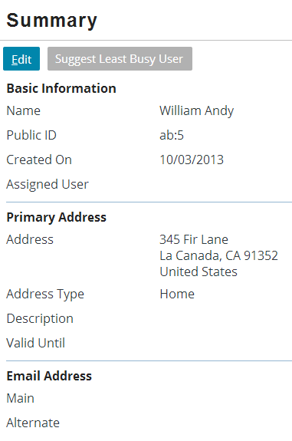

1. Reload the PCF files.
2. Add a toolbar button to the toolbar that appears at the top of the Employees list. The button should meet the following criteria:

* The button label is "Cascade Email Address"
* The button is available only if the company has an email address and only if the interface is in edit mode. In the example below, the company has an email address.
* When clicked, the button executes a PCF method that copies the company's email address to all employees who do not already have an email address. The method should not affect employees with an email address.

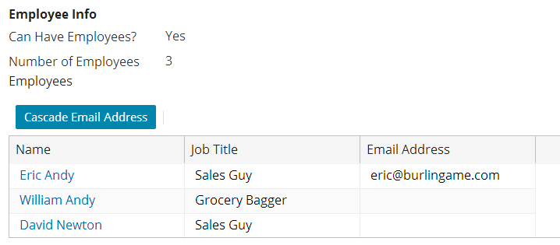

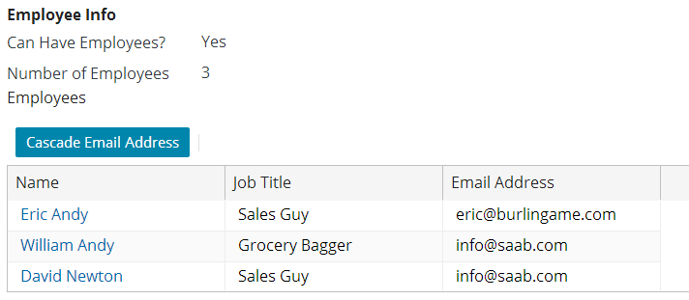

Verification

To test the PCF method:

1. Access the record for an ABCompany with an email address and ensure it has at least two employees. By default, the ABCompany “Albertson’s” has an email address.
2. Add an individual email address to one of the employees (such as William Andy, who in the screenshot above has an email address of "eric@burlingame.com").
3. Click the Cascade Email Address button. Verify that the employees with email addresses have not been changed, but the employees without email addresses now have the company's email address.
4. Click Update to commit the changes.
5. Access the record for one of the contacts that received the cascaded email address (William Andy, for example) and verify that the data was committed.

|  |  |
| --- | --- |
|  | Stop and ask your instructor to review your completed lab. |